**Observational Problem**

**Main Telescope**

1. Point your telescope to NGC 6475

RA (J2000): 17h 53m 54s

Dec (J2000): -34o 49”

Validate your object to your telescope assistant. (20 Point)

1. Write down the cardinal direction (North, South, East and West) on Chart 1 in the answer sheet. (10 Point)
2. Find 3 missing stars on Chart 1 based on the object you have observed. Mark the position of the missing stars with crosses (X). (25 Point)
3. Given that the magnitude of star A, B and C are 7.6, 7.2, and 5.6 respectively. Estimate and write down the magnitude of the missing stars beside each mark you have given. (20 Point)
4. Estimate the FOV of the eyepiece in this observation, stopwatch provided. Show your calculation in the answer sheet. (25 Point)

Anwer Sheet

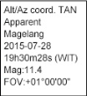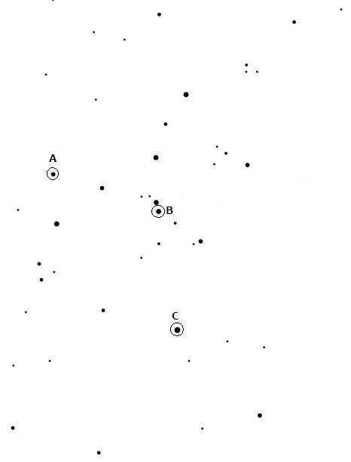

Chart 1

Solution,  
1. Checklist: (Telescope Assistant)  
- Object Accuracy (Right Object = Full Score).

Answer

No 2 (Cardinal Point) Each Correct Cardinal Point (Quarter Score)

No 3 (three missing stars) Region 1 (Full Score), 2 (Half Score), 3 (Quarter Score)

Note: The region are marked with the circles (region will be chosen during the IBM)

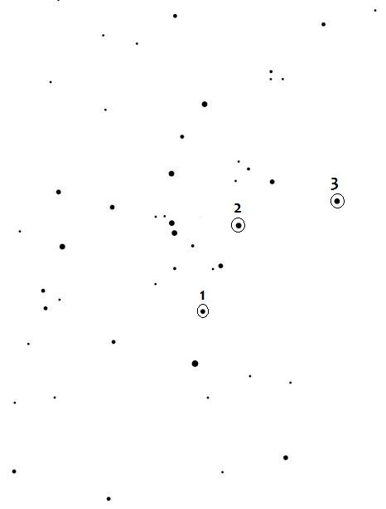

S

N

W

E

4. Missing Stars: 1. 7.4

2. 6.4

3. 7.0

Score Range:

±0.2 = Full Score  
±0.5 = Half Score  
±0.8 = Quarter Score

1. Using the 15mm (eyepiece), the field of view of the instrument is: 0.75o

* Using stopwatch to measure the time for a star to travel from the center of the FOV to the edge of the FOV. (Half Score)
* Using stopwatch to measure the time for a star to travel from the edge of the FOV to the other edge of the FOV (Quarter Score)
* Calculating the FOV,

$$FOV\left(deg\right)=\frac{Travel time\left(sec\right)}{23h 56m}xcos(δ)x360deg$$

(Half Score)